ASSIGNMENT-3
SQL operators, comparison, like

- Display all the employee’s information whose job is Clerk.
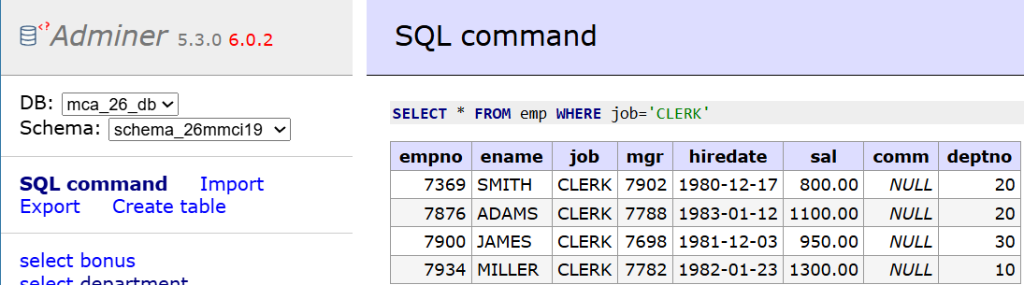
A: SELECT * FROM emp WHERE job='CLERK';
- Display all the employee’s information whose employee number is 7788.
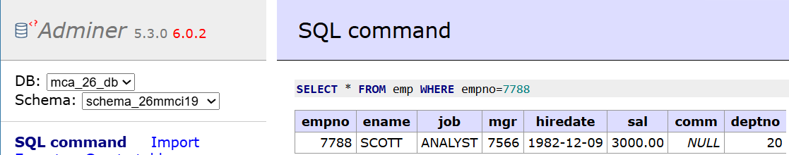
A: SELECT * FROM emp WHERE empno=7788;
- Display all the employee’s information whose commission is greater than his salary.
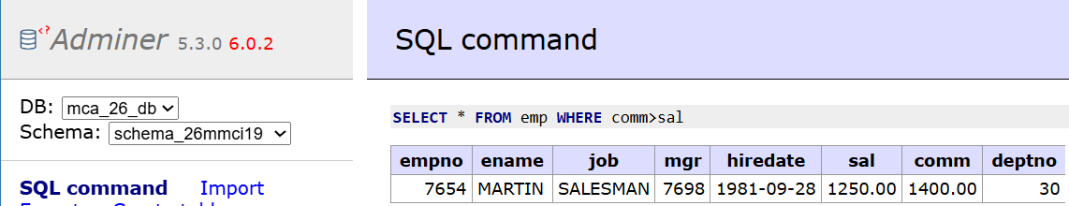
A: SELECT * FROM emp WHERE comm>sal;
- Display all the employee’s information those who are drawing a salary between 1000 and 2700.
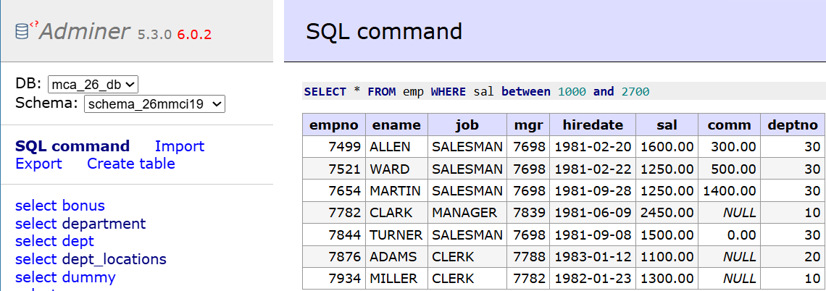
A: SELECT * FROM emp WHERE sal between 1000 and 2700;

- Display all the employee’s information whose employee number falls within a certain list.
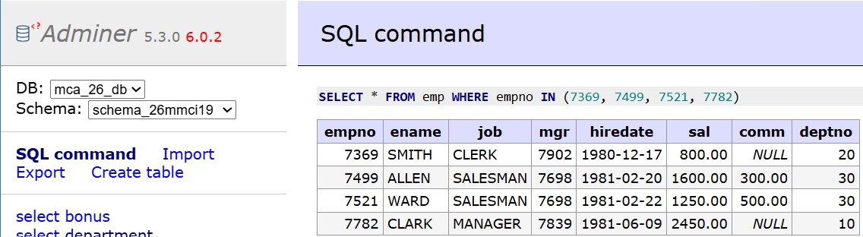
A: SELECT * FROM emp WHERE empno IN (7369, 7499, 7521, 7782);
- Display all the employee’s information those whose commission is not known.
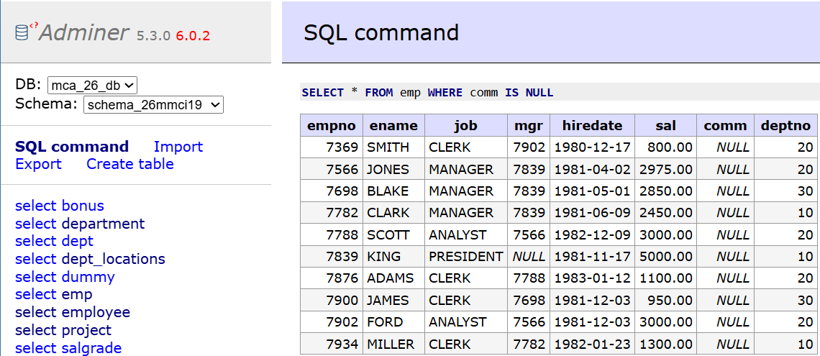
A: SELECT * FROM emp WHERE comm IS NULL;
- Display all the employee’s information whose employee name starts with an alphabet 'S'.
A: SELECT * FROM emp WHERE ename LIKE 'S%';
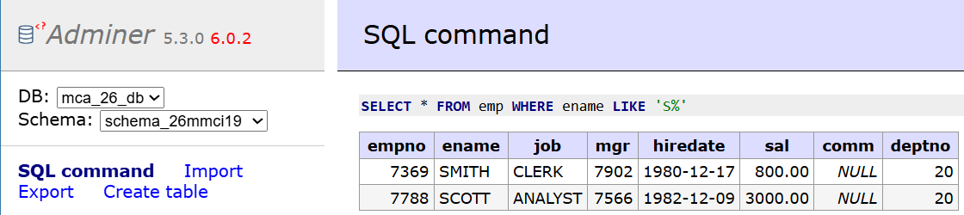
- Display all the employee’s information whose employee name's third alphabet is 'O'.
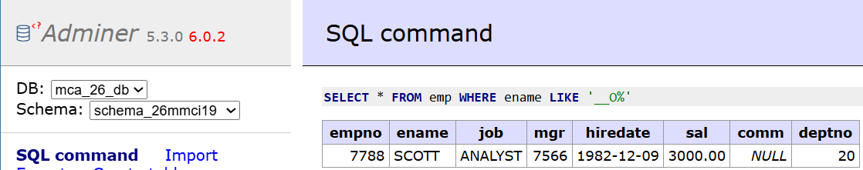
A: SELECT * FROM emp WHERE ename LIKE '__O%';

- Display all the employee’s information whose employee name is of four characters only.
A: SELECT * FROM emp WHERE ename LIKE '____';
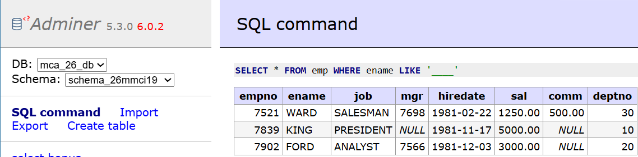
- Display all the employee’s information whose job is like "MANAGER".
A: SELECT * FROM emp WHERE job LIKE 'MANAGER';
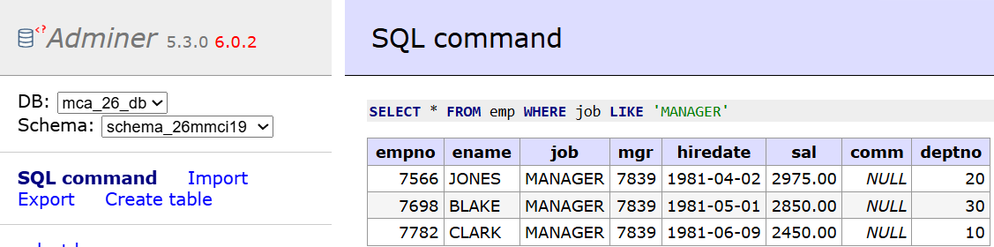
- From Q. No. 4 to Q. No. 10, write the queries using in negative sense.
Q4. Display all the employee’s information those who are drawing a salary between 1000 and 2700.
A: SELECT * FROM emp WHERE sal NOT BETWEEN 1000 AND 2700;
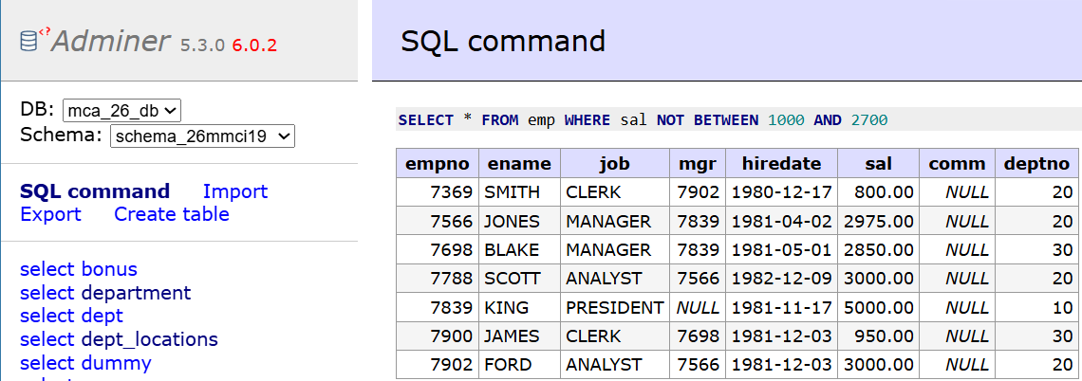
Q5. Display all the employee’s information whose employee number falls within a certain list.
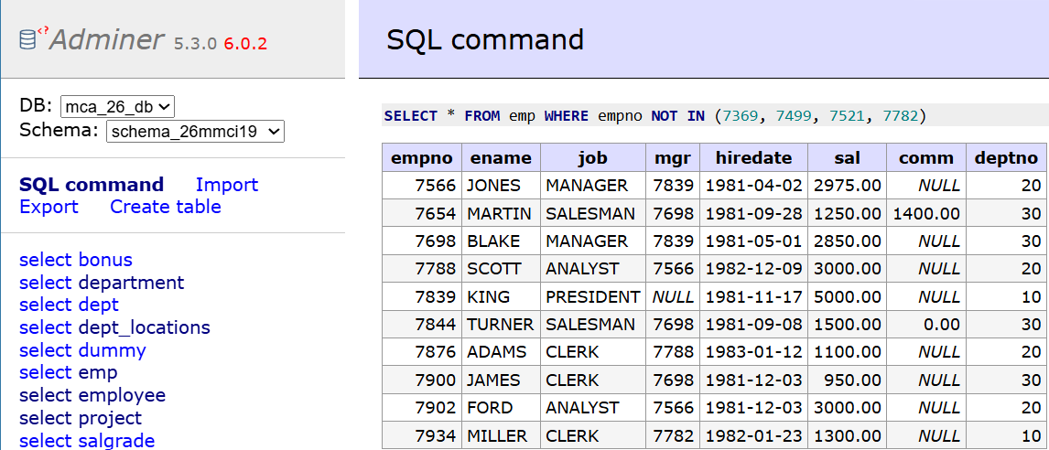
A: SELECT * FROM emp WHERE empno NOT IN (7369, 7499, 7521, 7782);

Q6. Display all the employee’s information those whose commission is not known.
A: SELECT * FROM emp WHERE comm IS NOT NULL;
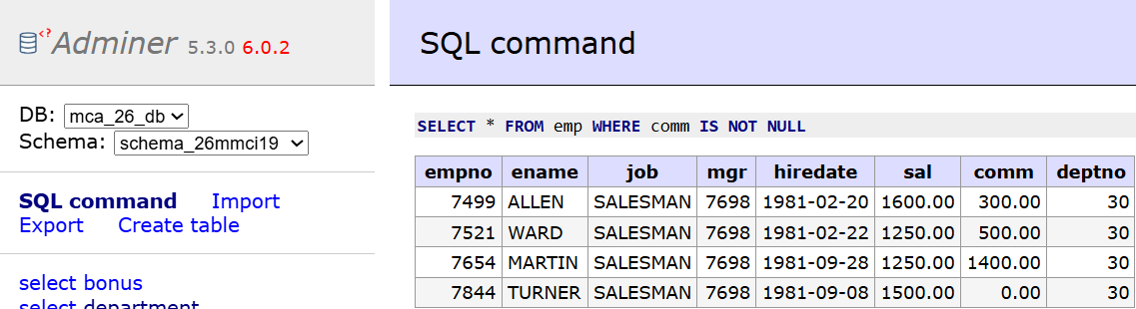
Q7. Display all the employee’s information whose employee name starts with an alphabet 'S'.
A: SELECT * FROM emp WHERE ename NOT LIKE 'S%';
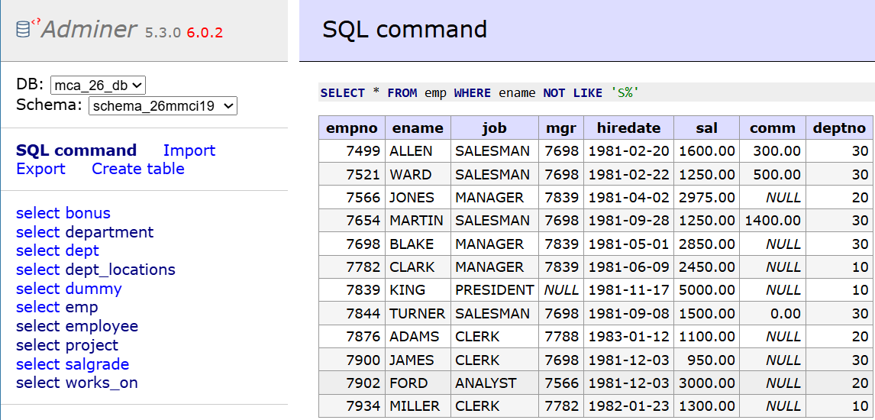
Q8. Display all the employee’s information whose employee name's third alphabet is 'O'.
A: SELECT * FROM emp WHERE ename NOT LIKE '__O%';
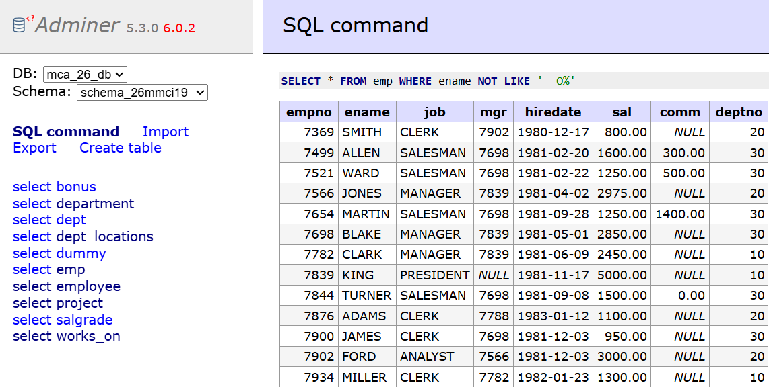
Q9. Display all the employee’s information whose employee name is of four characters only.
A: SELECT * FROM emp WHERE ename NOT LIKE '____';
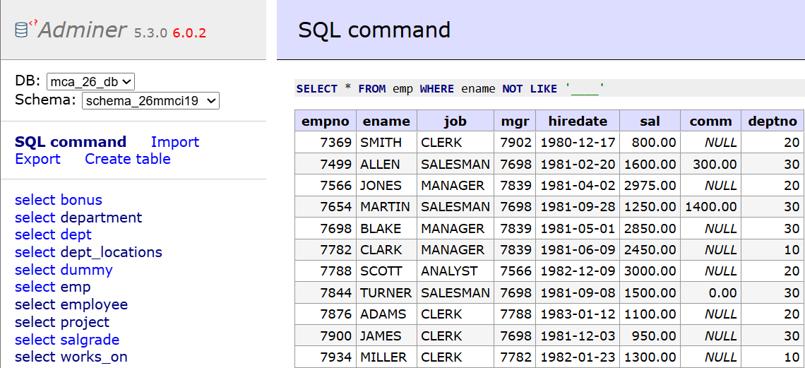
Q10. Display all the employee’s information whose job is like "MANAGER".
A: SELECT * FROM emp WHERE job NOT LIKE 'MANAGER';
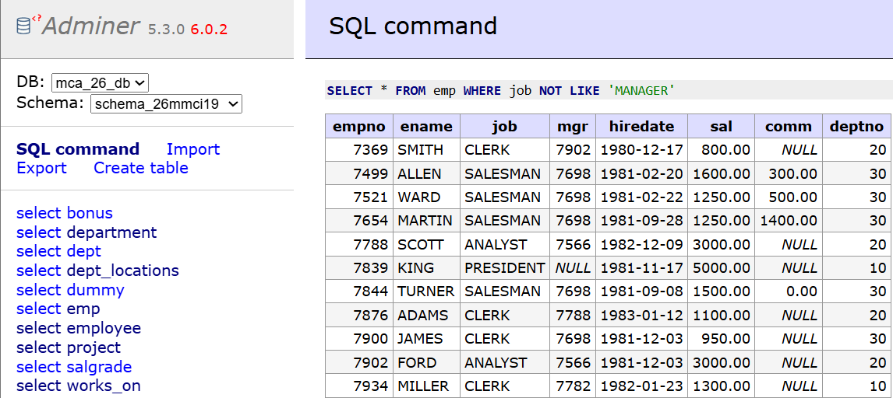
- Display the sum of salary and commission for each employee.
A: SELECT ename, sal + comm FROM emp;
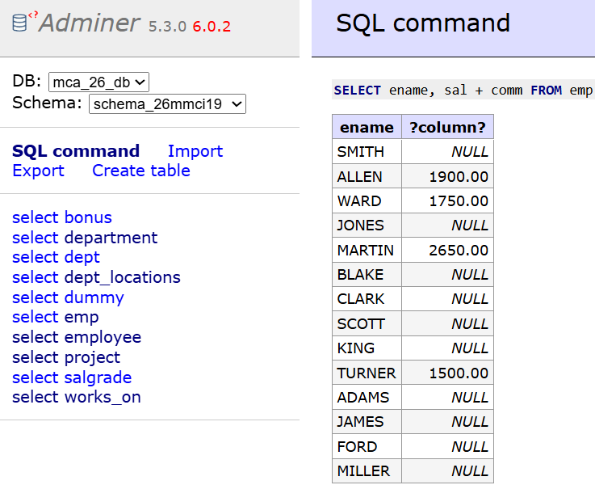
- Display the sum of salary and commission for each employee by replacing commission with 100 for employees whose commission is not known or commission is 0.
A: SELECT ename, sal + COALESCE(NULLIF(comm, 0), 100) FROM emp;
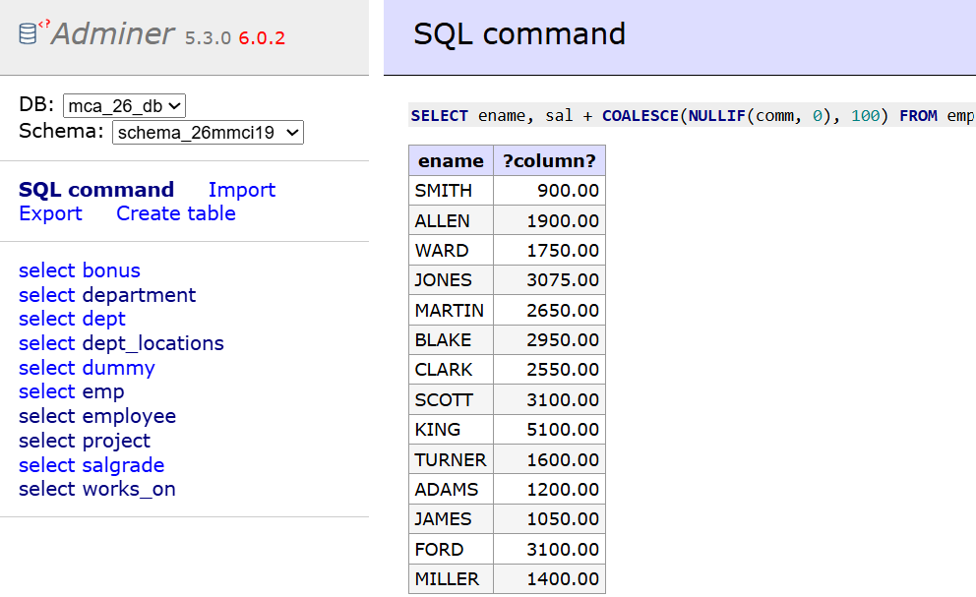

- Display each employee's name, annual remuneration by giving a suitable alias for annual remuneration.
A: SELECT ename, sal * 12 AS annual_remuneration FROM emp;
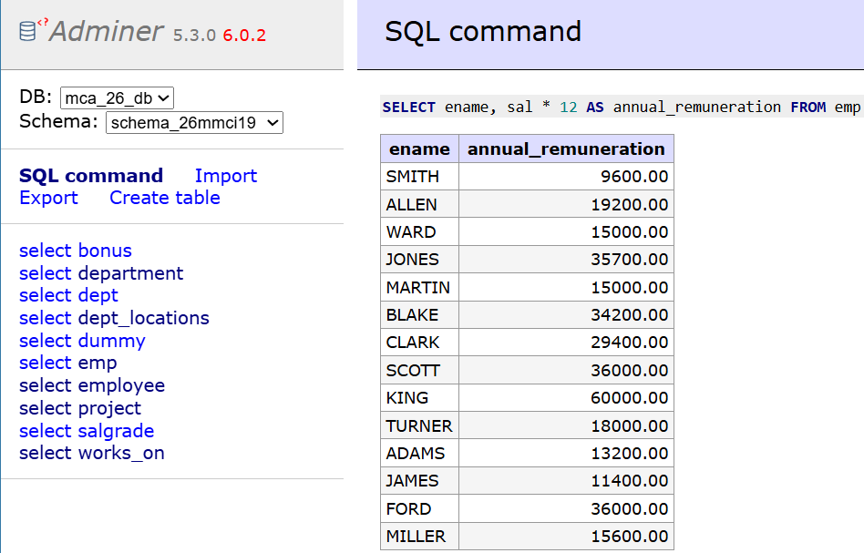

- Display all the employee’s information whose salary is greater than 2000 and job is according to your choice.
A: SELECT * FROM emp WHERE sal > 2000 AND job = 'ANALYST';

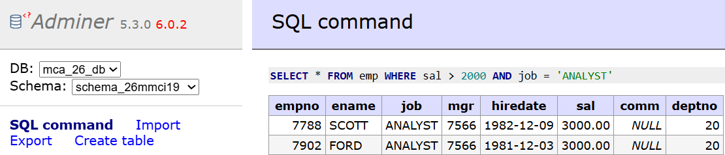
- Display all the employee’s information whose salary is greater than 3000 or job is according to your choice.
A: SELECT * FROM emp WHERE sal > 3000 AND job = 'MANAGER';
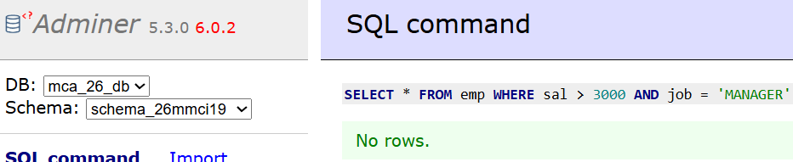
- Display all the employees who are working under department 20 and not drawing a salary greater than 2000.
A: SELECT * FROM emp WHERE deptno = 20 AND sal <= 2000;
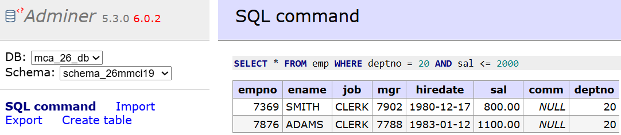
- Display all the employees who are drawing a salary greater than 2000 and whose job is either manager or job of your choice.
A: SELECT * FROM emp WHERE sal > 2000 AND job IN ('MANAGER', 'CLERK');
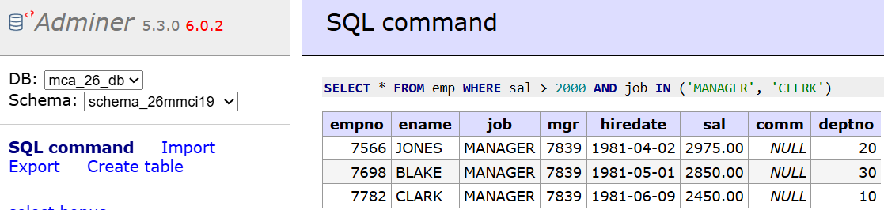
- Display the names like WARD, FORD from EMP table using pattern matching.
SELECT * FROM emp WHERE ename LIKE 'WARD' OR ename LIKE 'FORD';
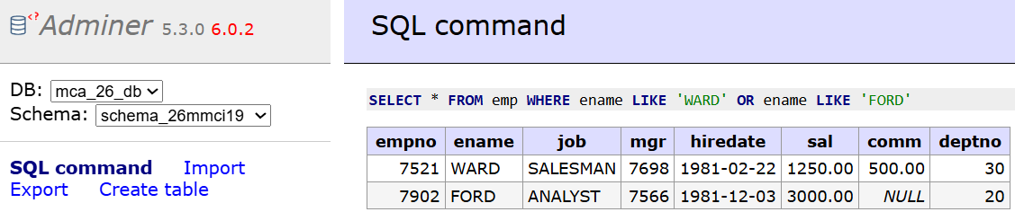
- Write a query using a pattern matching to display the names like SMITH_CLERK, ADAMS_CLERK from EMP table. HINT: USE CONCATENATION and LIKE Operator.
A: SELECT * FROM emp WHERE ename || '_' || job LIKE 'SMITH_CLERK' OR ename || '_' || job LIKE 'ADAMS_CLERK';
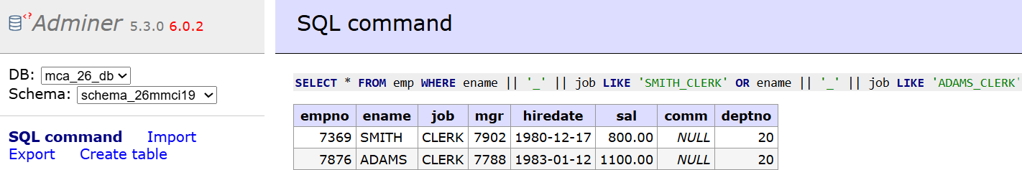
- Write a query using a pattern matching to display the names like %ALLEN_SALESMAN, %ADAMS_CLERK from EMP table. HINT: USECONCATENATION and LIKE Operator.
A: SELECT * FROM emp WHERE ename || '_' || job LIKE '%ALLEN_SALESMAN' OR ename || '_' || job LIKE '%ADAMS_CLERK';
